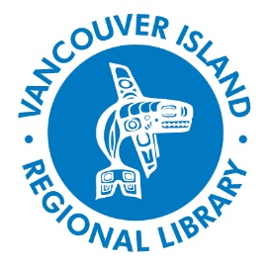
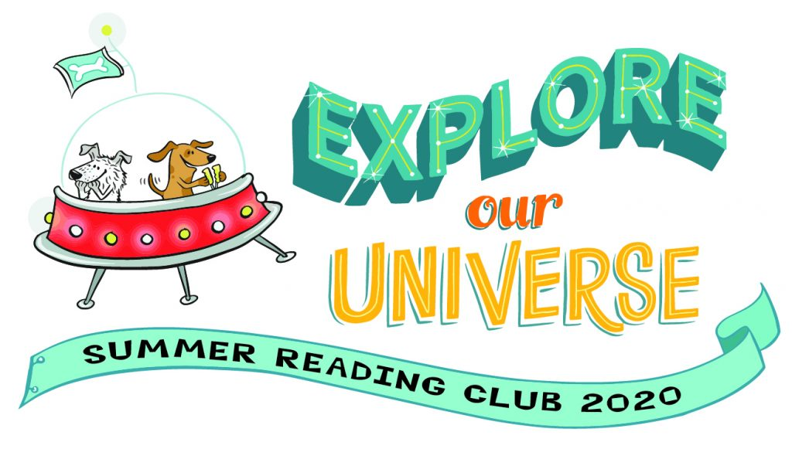

Attention Kids! It’s time to Explore Our Universe with the 2020 Summer Reading Club!

The Summer Reading Club (SRC) takes off on Monday, June 29 and runs until Saturday, August 15.

What’s new for 2020?
- We've gone virtual! Sign up and participate online
- Kids can set their weekly reading goals and earn digital badges
- The Kerplunks will perform a special kick-off live online on July 2
- Dr. Jay Cullen from the University of Victoria will talk online about his experience going through the Canadian Space Agency’s Astronaut selection process!
- SRC 2020 Author/Artist Bambi Edlund will present a virtual workshop and Q&A
- Award winning author Monique Gray Smith will read some of her children’s books and tell stories online
- Wolf educator Gary Allan, his friendly wolf Tundra and two other wolves will host a virtual program about wolves
- Authors Jeremy and Hermione Tankard will join fans online to talk about their new book Yorick and Bones. SRC participants can enter a special coloring contest that the Tankards will judge. The winner will receive a Jeremy Tankard bag of books.

Registration is NOW open! Visit https://bcsrc.ca/. You can also visit virl.bc.ca/summer-reading-club in the coming days for info about more virtual events, scavenger hunts and other programs.

Questions about SRC? Or can’t participate virtually? Contact us at 1-877-415-8475 or src@virl.bc.ca for more information.

Vancouver Island Regional Library is sponsoring the BC Summer Reading Club, in cooperation with the British Columbia Library Association, with funding from the Libraries Branch, BC Ministry of Education, and CUPE BC.

