**Child Passenger**

**Safety Clinic**

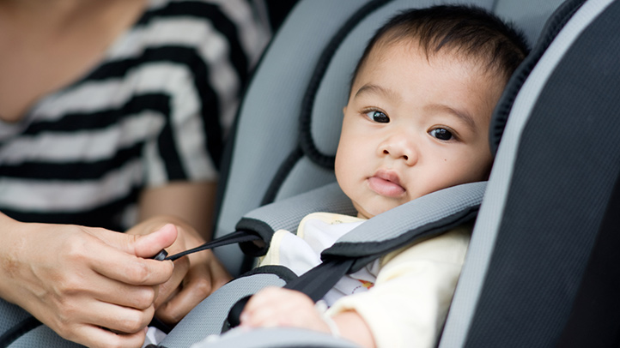

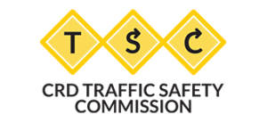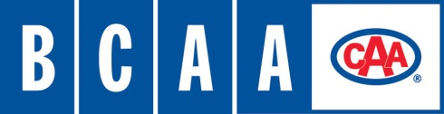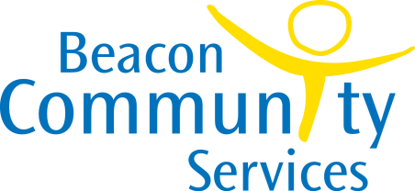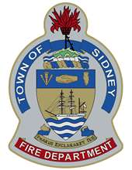

**Saturday, November 25, 2017**

**10am – Noon**

**Certified Child Passenger Safety Educators can check the installation of your child’s car seat inside the Sidney Fire Department Hall.**

**Sidney Fire Department**

**9837 Third Street, Sidney**