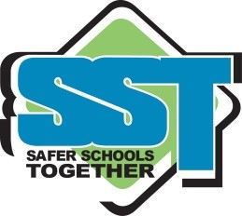
SAFER SCHOOLS TOGETHER
14788 Russell Avenue, White Rock, B.C., V4B 2P2
Tel: (604)560-2285 Email: saferschoolstogether@gmail.com
www.saferschoolstogether.com

PARENT ADVISORY
October 7th, 2016
“Clown” Related Threats
As you have been made aware throughout media and social media we have had a number of ‘Clown’ specific threats. These threats are typically referencing kidnapping or targeting schools with threats of violence.
All school districts, many independent schools and band schools in BC have, through the ERASE Bullying Strategy, received training in assessing and responding to threat related behaviour.
The majority of these threats are appearing throughout social media platforms primarily through Instagram and Snapchat accounts. Law Enforcement and Safer Schools Together have been involved in investigating similar pages that have been created throughout the country but there has been no violence reported at this time.

It is imperative that you talk to your children about reporting these threats if they see them on social media and bring them to the attention of school officials and/or law enforcement.
It is also important to make students aware that if they engage in, or participate in any way, in this type of threat related behaviour they will be experience discipline and/or criminal charges.
Many students see this as a prank and not as a criminal behaviour.
If you require any further information, please talk to your school administrators.

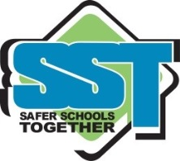
Theresa Campbell

